DBSCAN Clustering Algorithm

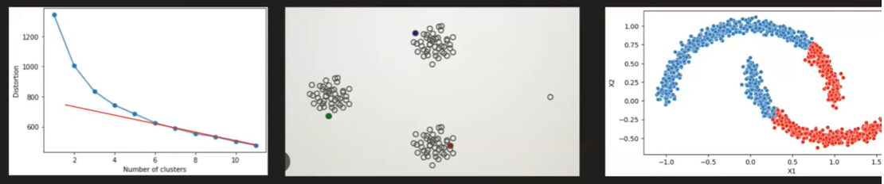
- Need to have k defined
- Sensitive to outliers
- Centroid based clustering algorithm – non spherical data
K means is centroid based clustering whereas DBSCAN is density based

Sparse Area

DBSCAN – Density Based Spatial Clustering of Applications with noise

EPSILON
𝜖
(eps) is the maximum distance for two points to be considered neighbors, crucial for defining dense regions.
Min Points = number of points
Helps to calculate the density around a point. Used a hyperparameters
Sparse
Dense

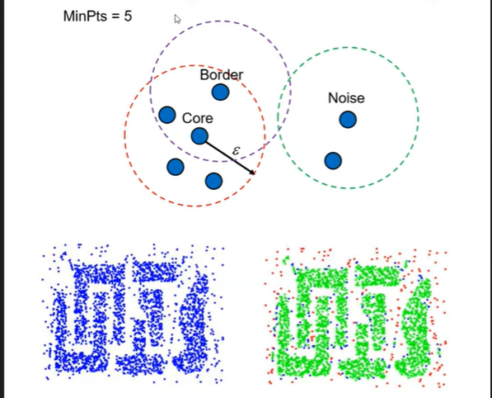

Core Point – A point which has greater than or equal to Min Points in its epsilon distance
Border Point - A point which has less number of points than Min Points in its epsilon distance but have atleast one core point
Noise Point – The point that is neither core nor border point

Density connected points

If 2 points are density connected then they can be combined together in one cluster

But how can we know if the points are Density connected?

2 Criteria
- All the in between points needs to be core point
- The distance between any 2 core points should be less than or equal to epsilon distance
If both the criteria are met, its density connected

If any one criteria is not met, points are not density connected

Steps
Decide min point and epsilon value

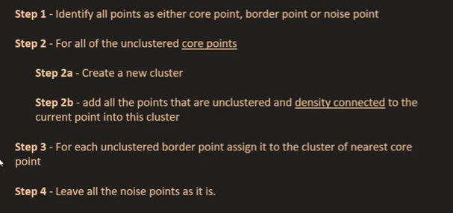

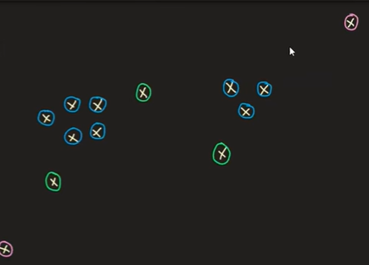
Blue – Core Points
Green – Border Points
Pink – Noise Points

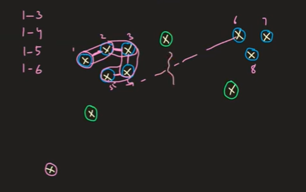

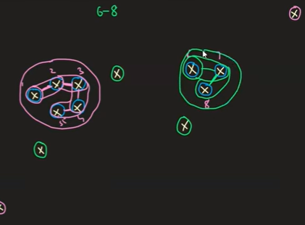

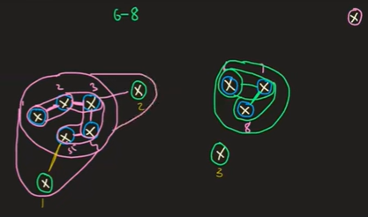

Advantages
- Robust to outliers – noise point (Anomaly detection)
- Don’t have to specify k value beforehand
- Can work with arbitratory data (shape does not matter)

Limitations
- Careful about hyperparameters
- Difficulty with varying density clusters



Questions
1. What does DBSCAN primarily use to identify clusters?
A. Centroids
B. Density of data points
C. Random initialization
D. Hierarchical merging

2. Which two parameters are required for DBSCAN?
A. n_clusters and linkage
B. eps and min_samples
C. k and max_iter
D. depth and gamma

3. In DBSCAN, a core point is defined as:
A. A point with no neighbors
B. A point with at least min_samples points within eps radius
C. A point on the outer boundary of a cluster
D. A centroid of a dense region

4. What happens to points that do NOT belong to any cluster in DBSCAN?
A. They are forcibly added to the nearest cluster
B. They are labeled as noise/outliers
C. They are removed from the dataset
D. They become new cluster centers

6. DBSCAN performs poorly when:
A. Clusters have non-uniform density
B. Data is very high-dimensional
C. The number of clusters is known
D. Outliers are present

7. Which distance metric does DBSCAN use by default in scikit-learn?
A. cosine
B. manhattan
C. euclidean
D. mahalanobis

8. A border point in DBSCAN is:
A. A noise point
B. A point with fewer than min_samples neighbors but inside eps of a core point
C. A point that forms its own cluster
D. A centroid of a sparse region

9. Which statement is TRUE about DBSCAN?
A. It requires the number of clusters to be pre-specified
B. It is sensitive to eps and min_samples parameters
C. It requires labeled training data
D. It always produces the same labels regardless of parameter settings

10. What is a major advantage of DBSCAN?
A. It is fast for extremely large, high-dimensional datasets
B. It guarantees optimal clusters
C. It automatically detects noise and outliers
D. It requires no distance metric

